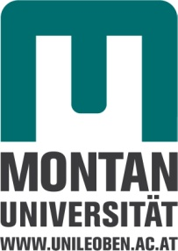

Gemeinsames
SEMINAR

Institut für Physik und Institut für Mechanik
aus
Halbleiterphysik und Nanotechnologie

Di, 20.3.2018, 13:00 Uhr, Hörsaal für Physik

“Synergies and differences between Helium implantation and displacement damage in metals: Mechanical properties and micro structure”

Prof. Dr. Peter Hosemann
Department for Nuclear Engineering, University of California Berkeley, CA, USA,

Nuclear engineering provides some of the most interesting materials science challenges combining physical, chemical and nuclear properties of matter driving materials selection to multi-dimensional space. Ionizing radiation can lead to multiple degradation mechanism. Displacement damage leads to non-equilibrium point defect concentrations further fostering the development of dislocation loops, stacking fault tetrahedrons, voids and enhanced or dissolving precipitation in alloys. Transmutation of elements can lead to the build-up of noble gases like Helium which can form He bubbles. While both lead to changes in microstructure and properties the nature of both defects is rather different. Small scale mechanical testing in combination with ion implantation enables separate effects testing and uncover the different deformation processes taking place in an efficient fashion. This presentation aims to highlight the different phenomena on recent examples relevant to nuclear applications.

